HALF SUBTRACTOR USING NAND GATES

AIM: To construct half subtractor using nand gates in logicism

INPUT:

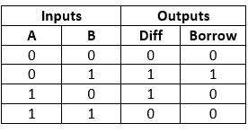

OUTPUT:

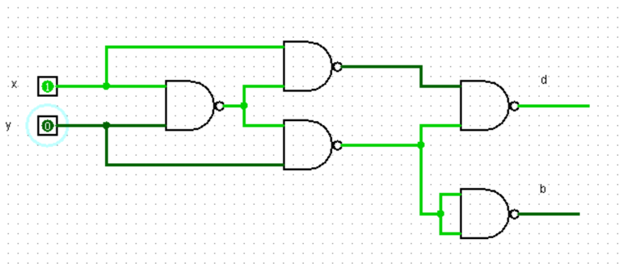

RESULT:

Thus completed successfully.